IN SITU SOIL-SPECIFIC NONLINEAR PROPERTIES
BACK-CALCULATED FROM VERTICAL ARRAY RECORDS DURING 1995 KOBE EARTHQUAKE

Takaji Kokusho¹, Member, ASCE, Tomohiro Aoyagi² and Akihiro Wakunami²

Abstract: In situ nonlinear soil properties are investigated based on vertical array records obtained during the 1995 Hyogoken Nambu earthquake (Kobe earthquake) at soft soil sites near the earthquake fault zone. Spectrum ratios between ground surface and deeper levels are calculated for the main shock and associated small shocks and S-wave velocities and damping ratios in surface soil layers to best reproduce them are back-calculated by means of an inversion analysis (Extended Bayesian Method) assuming 1-D vertical SH-wave propagation. Obvious differences in S-wave velocities and damping ratios are found between the main shock and the small shocks. Clear strain-dependent modulus degradations which can be differentiated for different soil types are recognized. The degradations are essentially consistent with some of laboratory test results to date for each soil type at least for G/G₀0.5 or larger, though for gravelly soils back-calculated values tend to show milder degradations than laboratory test results presumably due to large inclusion of fines in actual ground. Back-calculated damping ratios show essentially the same trend as in laboratory tests, although the absolute values are in most case a few percent higher in the strain range smaller than 10⁻⁴.

Key words: seismic site amplification, vertical array records, back-calculation, modulus degradation, damping

INTRODUCTION

Local site amplification is one of the most important factors in seismic zonation studies. The site amplification is correlated to not only to soil thicknesses but also soil properties such as wave velocities and material damping as well as soil densities. At the same time, it is expected to be highly dependent on the nonlinearity of soil properties at soft soil sites during destructive earthquakes. In 1970s’, analytical tools for nonlinear seismic response of soft ground due to nonlinear soil properties were already available either by equivalent linear analyses (Schnabel et al. 1972) or step-by step nonlinear analyses (e.g. Constantopoulos et al. 1973). Shake table tests for model ground in a laminar shear box repeatedly demonstrated a clear reduction in dynamic amplification due to nonlinear soil properties by increasing input acceleration level (e.g. Kokusho et al. 1979). However, due to absence of vertical array records of actual strong earthquakes, the degree of nonlinearity actually associated with strong ground motions has long been subject to discussions among researchers from different disciplines including seismologists.
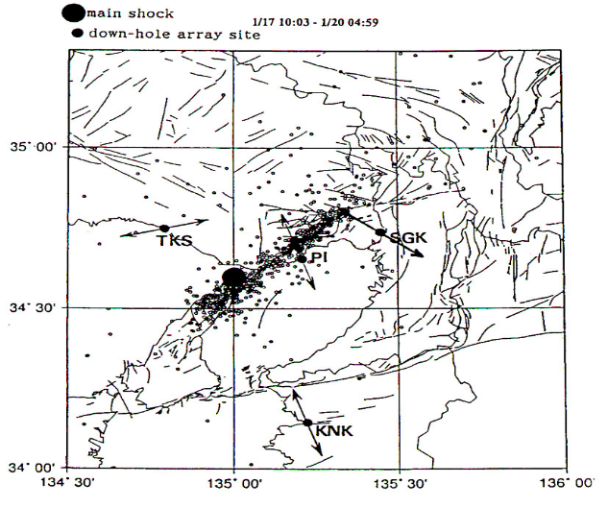
Fig.1 Locations of vertical array sites around Osaka Bay and the earthquake epicenters.

____________________________________________________________________________________
¹Professor, Civil Engineering Department, Faculty of Science and Engineering, Chuo University, 1-13-27Kasuga, Bunkyo-ku, Tokyo, 112 Japan.
²Ex-graduate student, Ditto.
In this research, valuable vertical array records obtained during the 1995 Hyogoken Nambu earthquake (sometimes called as the Kobe earthquake) as well as small events before and after it are utilized to evaluate site amplification between ground surface and deeper levels and the degree of strain-dependent nonlinearity. Fourier spectrums and their ratios between two levels are calculated for the main shock and small shocks. The spectrum ratios are then incorporated to back-calculate in situ soil properties, S-wave velocities and damping ratios, which are compared with laboratory test results to examine their applicability in the field.
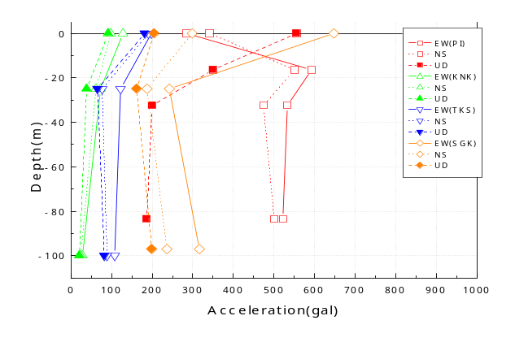
Fig.2 Maximum accelerations along depth at 4 vertical array sites.

VERTICAL ARRAYS AND SITE CONDITIONS
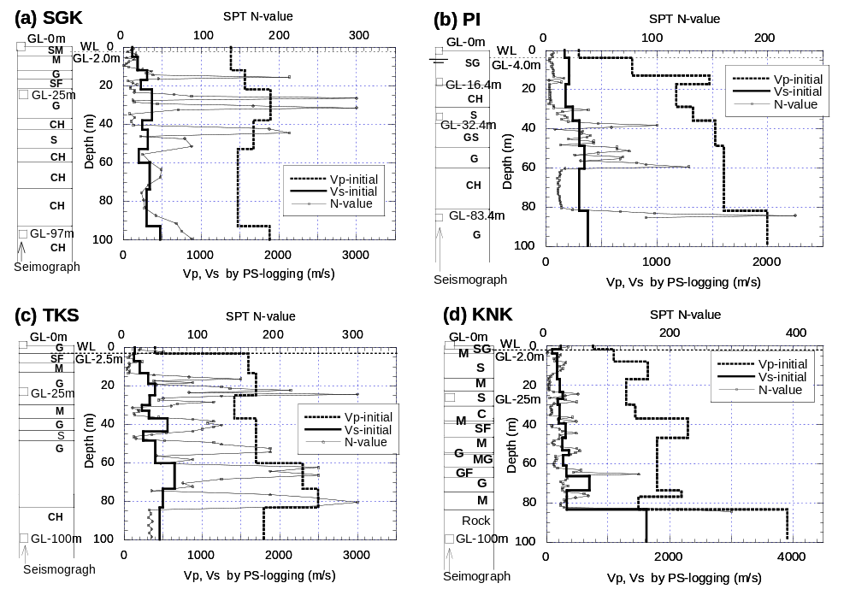
Fig.3 Soil profiles, SPT N-values, P/S-wave velocities (Vp/Vs) along depth at 4 sites;
- SGK, (b)PI, (c) TKS, (d) KNK.

Vertical arrays, which could record the 1995 Hyogoken-Nambu earthquake (M_{J}=7.2: the Japanese Earthquake Magnitude almost equivalent to the Richter’s Magnitude) were located at four sites in the coastal zone around the Osaka-Bay area as shown in Fig.1. The same figure also indicates the fault zone including the epicenters of the main-shock as well as aftershocks. The four sites were located in different distances from the focal area, which can be estimated from the numerous aftershock epicenters plotted in Fig.1. The PI (Port Island) array belonging to the Kobe Municipal Office was located just next to the fault zone, while other three arrays SGK, TKS and KNK belonging to the Kansai Electric Power Company were approximately 15km, 35km and 65km far from the earthquake fault respectively. In Fig.2, maximum acceleration distributions for the main shock along the depth of vertical arrays at the four sites are illustrated in the two horizontal directions and one vertical direction. The accelerations are extremely different from site to site, leading to different amplification characteristics (Kokusho and Matsumoto 1998).
The soil profiles and the installation depths of down-hole seismographs are shown for individual sites in Figs.3(a)-(d) together with the P and S-wave velocities measured by the down-hole logging method and the SPT N-values along the depth. The deepest seismographs at the base layers were located GL-97m at SGK, GL-83m at PI, and GL-100m at TKS and KNK respectively, and the geological conditions at the depths were Pleistocene dense gravelly soils except for KNK consisting of hard rock. Upper soil conditions at the four sites mostly consist of sandy fill at the surface underlain by Holocene clay and/or sand and further underlain by Pleistocene soils. The S-wave velocity, Vs, at the base layer of Pleistocene gravelly soil at PI, SGK and TKS is 380-480 m/s while Vs at the base rock at KNK is as high as 1630 m/s.

SPECTRUM RATIOS

At each site, several small shock records as well as the main shock record were used for evaluating spectrum ratios and back-calculating soil properties; five aftershock records at SGK, five small shock records occurred before the main shock (not necessarily foreshocks) at PI, four aftershock records at TKS and six aftershock records at KNK as listed in Table 1 together with their occurrence times, earthquake Magnitudes M_{J} (Japanese Magnitude almost equivalent to the Richter’s local magnitude M_{L}) and peak ground accelerations (PGA). All recorded motions, both the main shock and the small shocks, were first modified according to directional offset values of the buried seismographs which are available in other literature (Kokusho and Aoyagi, 2001).
Fourier spectra of seismic records obtained at the ground surface and deeper levels of the vertical arrays were calculated by the FFT scheme and smoothed by the Parzen window with the band width of 0.3Hz. Spectrum ratios between different levels were evaluated by the ratios of two Fourier spectra already smoothed by the window as a function of frequency. In Figs.4(a)-(d), spectrum ratios between surface and deeper levels for small shocks in the NS direction are shown for PI, TKS and KNK, respectively. The spectrum ratios evaluated for different small shocks at the same site are notably similar to each other in terms of their peak frequencies despite wide variations in amplitude, indicating that the soil layers tend to respond fairly consistently to different seismic inputs.
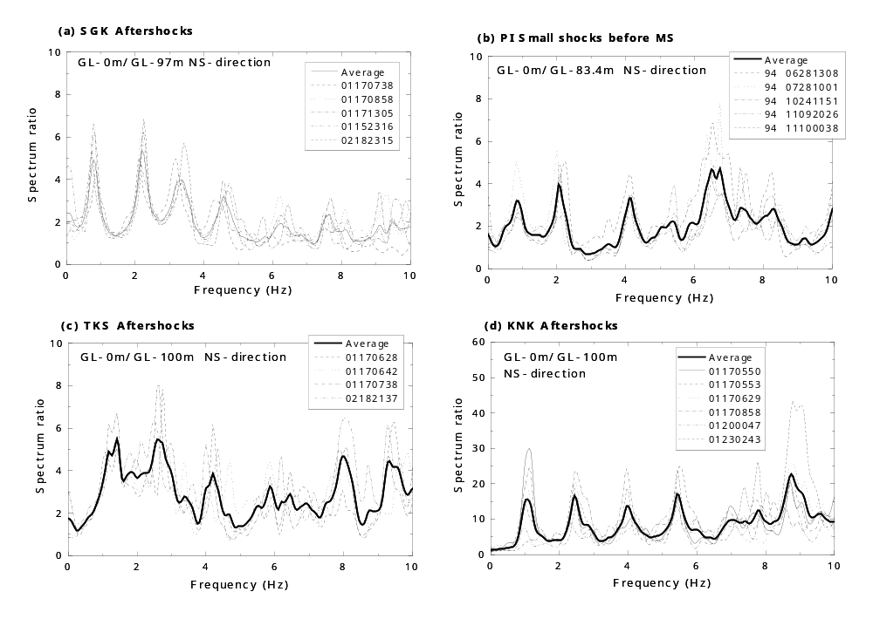
Fig.4 Spectrum ratios for small shocks at 4 sites; SGK, (b)PI, (c) TKS, (d) KNK.

In Figs.5(a)-(d), spectrum ratios calculated in the same way for the main shock at the four sites are compared with those of the small shocks in terms of their average and the average plus or minus the standard deviation. The spectrum ratios for the main shock are mostly smaller than those for the aftershocks although they are closer or sometimes reversed in the first peak. Peak frequencies of the main shock tend to be lower than those of the small shocks at most sites. This trend is more pronounced in the second or higher frequency peaks than in the first peak presumably because soil nonlinearity is more dominant in shallower layers, which influences higher frequencies more than lower ones. In PI, such comparisons of peak frequencies are almost impossible presumably because soil nonlinearity during the main shock was so significant due to extensive soil liquefaction. The differences in spectrum ratios and peak frequencies between the main shock and the small shocks tend to be narrowed as the vertical array sites are getting remote from the seismic fault; from the nearest PI, to the farthest KNK.
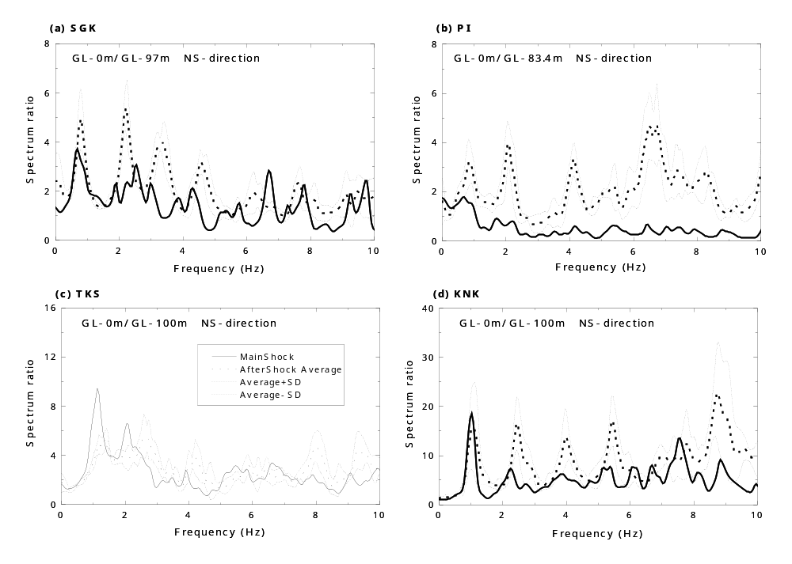
Fig.5 Spectrum ratios for main shock compared with small shocks at (a)SGK, (b)PI, (c) TKS, (d) KNK.

BACK-CALCULATION METHOD

In order to back-calculate in situ soil properties based on vertical array records, there are two different ways; direct and indirect methods. In both methods, the ground is modeled as a one-dimensional soil column consisting of horizontal layers in which the SH-wave vertically propagates as originally proposed by Kanai et al. (1966). In the former, soil layers are modeled by discrete elements and their stress versus strain relationships are directly computed from multi-level acceleration records in the time domain (Elgamal et al., 2001). In the latter, spectrum ratios of the vertical array records between different depths are first calculated in the frequency domain and equivalent linear soil properties are optimized to best reproduce them. Sato et al. (1996) and Kokusho et al. (1996) made inversion analyses by the indirect method, in which the conventional least mean square method was used. Only the main shock records were analyzed there to compare the back-calculated properties with initial properties based on in situ S-wave logging test results. In the present research, equivalent linear soil properties will be back-calculated by the indirect method using a more sophisticated computer code based on the Extended Bayesian method developed by Suetomi (1997). Not only the main shock records but also the small shock records are analyzed to have better estimation of variations of in situ soil properties with varying seismic intensity.
In the Extended Bayesian method, the observational spectrum ratios and the soil parameters, Vs and Q in this research, are dealt with, both of which are approximated statistically by the normal distribution. More specifically, a residual,, formulated by the following equation is to be minimized.

(1)

Here, 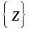 and 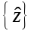 is vectors of measured and back-calculated spectrum ratios of the dimension 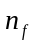, and 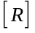 is a 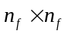 covariance matrix for the difference 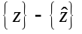, where is the number of data points in frequency domain. On the other hand, 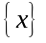 and 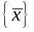 are back-calculated vectors and mean vectors, respectively, of soil properties with the dimension 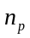, and 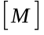 is a 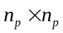 covariance matrix for 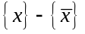, where is the number of back-calculated soil properties. Unlike the least mean square method, where only the first term of Eq.(1) concerning the observational information on the spectrum ratio is minimized, pre-observational statistical information on soil properties in the second term is also incorporated in this method in order to improve the reliability of the back-calculation. A constant in Eq.(1) serves to adjust the contribution of the pre-observational information relative to the observational information. The back-calculated spectrum ratio vector is theoretically correlated with soil parameters as

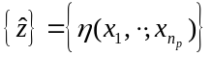 (2)

where 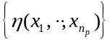 is generally a vector of the dimension at the frequency points. The function 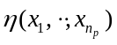 for the soil properties 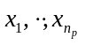, which is generally nonlinear may be approximated by the Taylor expansion around 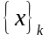 as

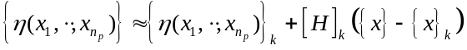 (3)

where 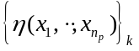 is a vector consisting of values of computed at 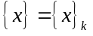 and 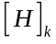 is a 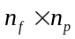 matrix computed from the first derivatives of in terms of around as

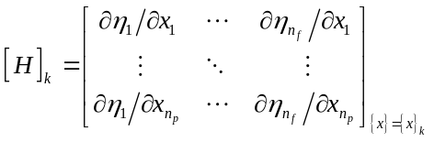 (4)

For minimizing Eq.(1),

(5)

Then,

(6)

Therefore, the vector can be iteratively calculated by the following equation, in which a new vector 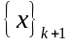 is derived from a previous vector .

(7)

The constant in Eq.(7) is decided so that the following Akaike-Bayes Information Criterion parameter takes a minimum value (Honjo, 1995).

(8)

in which 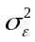 is the maximum covariance of the observational spectrum ratio. Eq.(8), which is valid when is a linear function of , is used here by assuming the nonlinearity of is not significant so long as the initial guess of the soil properties is not so remote from optimized values. More details on theoretical backgrounds on the Extended Bayesian Method for back-calculating soil properties based on seismic array records are available in other literatures (Honjo et al. 1998).
In this research the pre-observational information for analyses of the small shocks comprises averages and standard deviations in properties of individual soil layers; Vs measured by means of S-wave logging tests and Q estimated from accumulated database by lab soil tests. For the main shock analysis, the values of Vs and Q are modified in accordance with estimated strain level. The information is combined with the observed average spectrum ratio and its standard deviation for the small shocks to back-calculate Vs and Q not only for the small shocks but also for the main shock at the same site. Values of Vs and Q are postulated to be independent of frequency as in the normal geotechnical engineering practice. Soil properties shallower than the second deepest seismograph are first optimized by utilizing spectrum ratios between the surface and that level. Then, properties deeper than that are optimized based on spectrum ratios between the surface and the deepest level.

BACK-CALCULATION OF RECOEDED MOTIONS AT SGK-SITE

Back-calculation of soil properties for the main shock and small shocks is carried out for the four sites by the Extended Bayesian Method. In this section, results obtained by detailed back-calculation at the SGK-site are explained in detail. The SGK-site has been chosen here because, as shown in Table 1, not only the main shock but also a few aftershocks gave relatively large PGA at this site so that more detailed study on the soil nonlinearity effect seems worthwhile. The records used here are the main shock, MS, and five aftershocks classified here into 3 groups, AS-A, AS-B and AS-C.
The one-dimensional model and the initial soil properties at the SGK-site are summarized in Table 2. The model consists of 13 sublayers including the base layer. The initial guess for Vs is based directly on in situ S-wave logging test results for the aftershocks. Vs-values for the main shock are assumed by 30 – 8% smaller based on speculations considering strain-dependent nonlinearity. The initial values of D for aftershocks are estimated from hysteretic damping values by previous laboratory tests and those for the main shock are estimated by assuming earthquake-induced soil strain (Kokusho, 1987). The S-wave velocities and Q=1/(2D) are used as the mean values of the components in the soil parameter vector in Eq.(7). Concerning the variability of in situ Vs and Q, there exist very few available data. The variance coefficient is assumed here both in the aftershocks and the main shock as 25% for Vs and also for Q based on personal experience, and diagonal elements of the covariance matrix in Eq.(7) are accordingly decided. The off-diagonal elements are set zero by assuming no interaction effect between properties of individual layers.
Standard deviations of the observed spectrum ratios are calculated by dealing all the aftershocks AS-A, B, C as a single group by assuming that they share identical statistical properties despite differences in source parameters, focal distances and PGA values. They are indicated by dotted lines in Fig.4(a). The covariance matrix for the spectrum ratio is accordingly calculated from standard deviations in diagonal elements and zero in off-diagonal elements by assuming no interaction effect between spectrum ratios at different frequencies. The same is also used for the main shock because no variance information is available for the main shock spectrum ratio other than that for the aftershocks. The constant in Eq.(7) is parametrically shifted from 0.1 to 1.0 so that ABIC in Eq.(8) takes a minimum value (Honjo, 1995).
In Figs.6(a)-(c), optimized spectrum ratios (thick dotted lines) are compared with the observed spectrum ratios (solid lines) in the NS direction for AS-C, AS-B and AS-A, respectively. The top chart in each figure is the ratio in the upper layer between the surface (GL-0 m) and the middle level (GL-24.9 m). Similarly, the bottom chart is the ratio in the lower layer between the surface and the deepest level (GL-97.0 m). Thin dotted lines in the same figures indicate spectrum ratios based on soil properties of the initial guess. The observed spectrum ratios are reproduced not perfectly but satisfactorily in terms of frequency and amplitude by the back-calculation although the first peak height is obviously underestimated. Fig.6(d) shows the similar comparisons for the main shock. The agreement appears poorer than the aftershocks and higher frequency peaks are considerably underestimated. The chain-dotted curves in the figure represent for the optimized transfer functions obtained in the previous research using the conventional least mean square method (Sato et al., 1996; Kokusho et al., 1996). The degree of coincidence between the optimization and the observation is obviously improved by the Extended Bayesian method although the degree of improvement may not be so dramatic.
One of the conspicuous discrepancies observed in Figs.6(a)-(d) is underestimation in higher frequency peaks. The gap tends to widen with increasing intensity of the motions from the aftershocks to the main shock. This may be attributable to two different damping mechanisms involved in site amplification and disregarded in this analysis. The first is the hysteretic damping, caused by soil friction, hence, strain-dependent and frequency-independent, which is well recognized in geotechnical engineering. In irregular seismic motions, induced strain amplitudes tend to be larger in lower frequency ranges than in higher frequency ranges. Consequently, lower frequency cycles result in higher damping ratios on account of larger strain amplitudes than higher frequency cycles included in the same strong accelerogram. The cycle-by-cycle strain-dependent damping fluctuations cannot be taken into account in the equivalent linear approximation, in which optimized constant values represent intrinsically variable properties, resulting in too large damping ratio or too little amplification in higher frequency ranges.
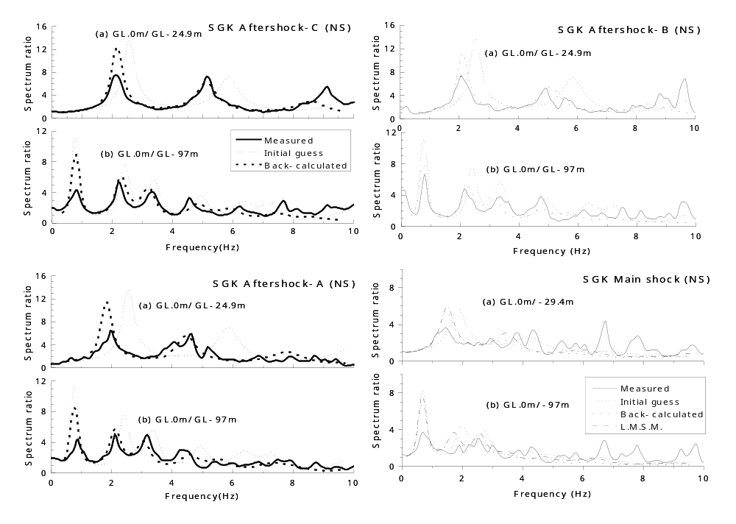
Fig.6 Spectrum ratios of recorded motions at SGK compared with back-calculated results; (a)AS-C, (b)AS-B, (c)AS-A, (d) MS.

The discrepancy between the optimization and the measurement is narrowed in the aftershocks compared to the main shock, because the strain-dependent nonlinearity is less dominant in the weak motions. However, a similar trend can still be recognized slightly in the aftershocks as shown in Figs.6(a)-(c). Intrinsic frequency-dependency of the damping ratio is hence suspected as another cause of the discrepancy, in which the damping ratio is smaller for higher frequency without the involvement of strain-dependency. This frequency-dependency in damping, which is hardly recognized in laboratory soil tests, has been demonstrated by seismologists based on wave attenuation observation in the earth crust. Though its accurate mechanism is not completely clarified, non-uniformity in actual soil deposits is considered to have something to do with it (Suetomi and Nakamura 1990). Based on the observations of Figs.6(a)-(d), it may be said that the damping mechanism for strong ground motions is mostly hysteretic nature, which the equivalent linear approximation cannot reproduce well, while there seems to be some contribution of intrinsic frequency-dependency of damping.
In order to examine the reliability of the back-calculation scheme employed here, some additional analyses for artificial motions synthesized by a one-dimensional multi-reflection linear soil layers model have been carried out. This model is exactly the same in terms of soil structures and soil parameters as those optimized at the SGK-site for the main shock and the aftershocks. The measured motions at the deepest installation levels are given to the model to compute synthesized motions at different levels, which are then used to back-calculate the prescribed linear soil properties. The computational procedures and parameters including the initial guess on Vs and Q are exactly the same as those which have been used in the analyses for measured motions explained before.
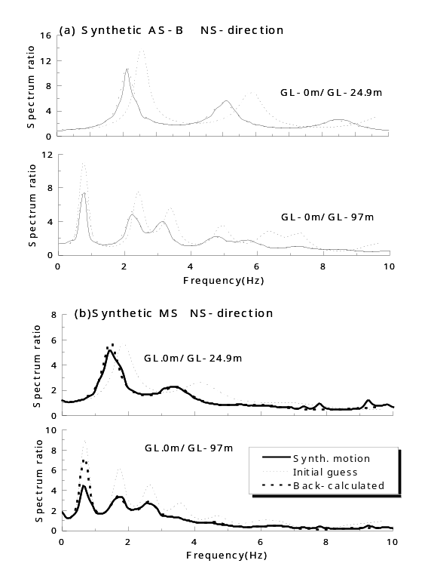
Fig.7 Spectrum ratios of synthetic motions at SGK compared with back-calculated results;
(a) AS-C, (b) MS.

Figs.7(a) and (b) show the back-calculated spectrum ratios compared with those of the synthetic AS-B and MS motions. The agreement looks almost perfect not only for the weak motion but also for the strong motion except for visible discrepancy in amplitudes at some of the first peaks. The disagreement in higher frequencies between measured and back-calculated spectrum ratios recognized in Figs.6(a)-(d) is not found here any more. Consequently, this back-calculation method seems mostly reliable as a tool for estimating idealized linear system, although there are apparent limitations for appreciating step by step soil nonlinearity and intrinsic frequency dependency of seismic motions. The poor agreement in the first peak is a defect commonly observed in Figs.6(a)-(d), the cause of which is not known at this stage of research.
S-wave velocities Vs thus back-calculated for the NS direction and also for the EW direction for the aftershocks and the main shock at the SGK-site are shown along the ground depth in Fig.8(a). It is noted first that the optimized values of Vs are almost identical in the EW and NS directions in all motions and overlapping to each other in several depths. The values of Vs for the aftershocks are evidently larger than those of the main shock. Among the aftershocks, AS-C tends to have the largest Vs than AS-A or AS-B, indicating that even the smaller differences of the seismic motions result in detectable changes in Vs. The initial values of Vs based on S-wave logging tests also drawn by a thin solid line in the same figure are similar to the back-calculated values for the aftershocks although a few evident discrepancies can be found in the layers shallower than 22 m.
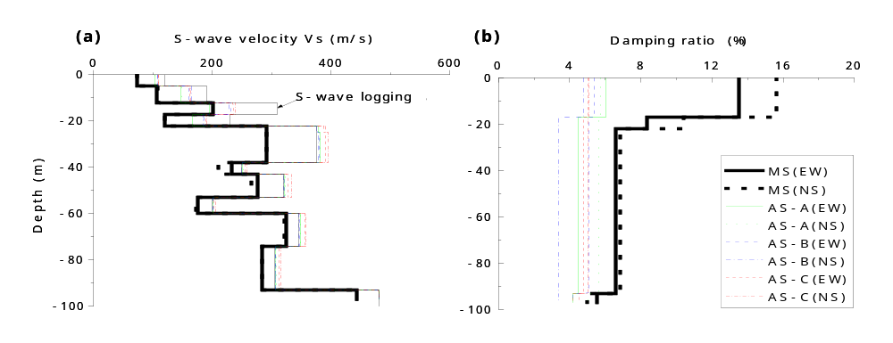
Fig.8 S-wave velocities and damping ratios along depth back-calculated for main shock and aftershocks at SGK; (a) S-wave velocities, (b) damping ratios.

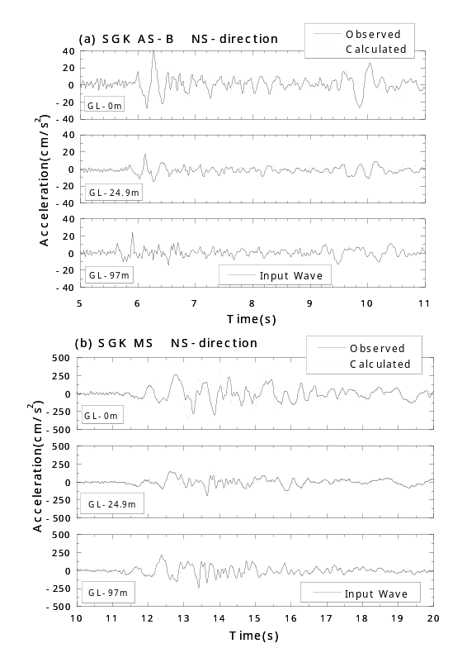
Fig.9 Acceleration time histories calculated by linear multi-reflection analysis compared with observed motions at SGK; (a) AS-B, (b) MS.

In Fig.8(b), the vertical distributions of the optimized damping ratio D, which is evaluated from the back-calculated Q-values by 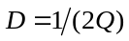 are shown. The values of D for the main shock are evidently larger than those of the aftershocks particularly in the shallow ground due to higher soil nonlinearity. Damping ratios for the aftershocks AS-A, AS-B and AS-C are not different so much to each other and larger aftershocks do not necessarily yield larger damping ratios probably due to poorer resolutions in back-calculating damping ratios than S-wave velocities.
Acceleration time-histories at the SGK-site are computed by the linear multi-reflection analysis by using the back-calculated properties and giving the recorded motion at the deepest level. The computed results are compared with the measured motions for AS-B in the NS-direction in Fig.9(a). The degree of reproduction seems satisfactory both in phase and in amplitude. The similar comparison for the main shock in the NS-direction is shown in Fig.9(b). Again the agreement does not seem so poor despite the obvious gap in the spectrum ratio shown in Fig.6(d) except for the ground surface motion where the maximum acceleration is somewhat overestimated.
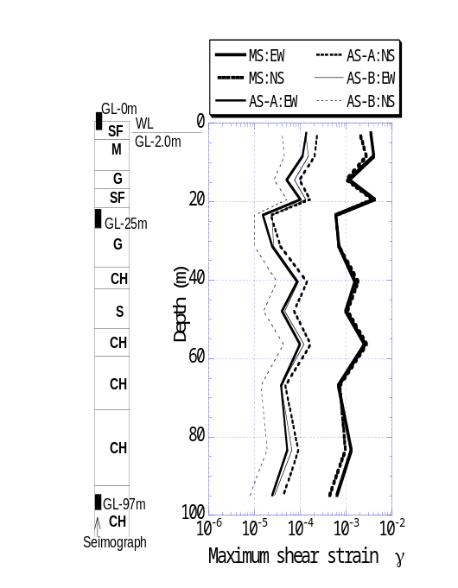
Fig.10 Calculated maximum strain for main shock and aftershocks along depth at SGK.

Based on the time histories for the main shock and the aftershocks computed in the same way, induced shear strains can be quantified for individual layers in the soil model in the EW and NS directions. Fig.10 shows the distributions of maximum strains 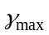 along the depth for MS, AS-A and AS-B. The strains evidently decrease as the input motion changes from MS to AS-A and AS-B. The strains for AS-C which actually include three aftershocks are not computed here but can be estimated to be around 1 x 10⁻⁵ or less. The effective strain 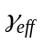 may be defined by 65% of the maximum strain as 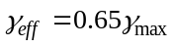 according to the normal practice employed in equivalent linear analyses.
Degradations of shear modului 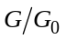 can be evaluated both in NS and EW directions by 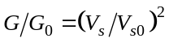 where 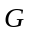 and 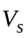 are back-calculated moduli and S-wave velocities, respectively, for the main shock and the larger aftershocks AS-A and AS-B. The corresponding small strain properties 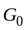 and 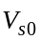 are assumed here as the back-calculated values of the smallest aftershock AS-C. This is a significant change from the previous papers by Kokusho et al. (1996) and Kokusho and Matsumoto (1998) in which in situ S-wave logging test results were used as . The change may be justified because S-wave velocities obtained by in situ tests are clearly different from back-calculated results down to the depth of 22 m as shown in Fig.8(a) and seem to be less reliable than the values back-calculated for AS-C.

STRAIN-DEPENDENCY OF BACK-CALCULATED INSITU PROPERTIES AT 4 SITES

Back-calculation has similarly been performed at PI, TKS and KNK-sites by the extended Bayesian method for the main shock and small shocks as described in other literatures (Aoyagi, 2000; Kokusho and Aoyagi, 2001). The results are incorporated here to have more generic strain-dependency of soil properties covering different site conditions. The small shocks in these sites had small accelerations as shown in Table 1, hence maximum shear strains were around or less than 110⁻⁵ in most soil layers. Consequently, soil properties for the small shocks are interpreted here as small-strain properties.
Shear modulus ratios and damping ratios thus calculated in NS and EW directions are plotted against logarithms of corresponding effective strains in Figs.11(a)-(d) for different types of soils; clay, silt, sand and gravel, respectively. The plots represent properties of individual soil layers in the soil profiles at the four sites illustrated in Figs.3(a)-(d). The soil classifications here are based on the Unified Soil Classification System, and C (CH), M , S (SF, SG) and G(GF, GS) stand for clay, silt, sand and gravel, respectively.. Clear strain-dependent modulus degradations can be recognized for every soil type at individual sites and also globally despite some data dispersions. The data points encircled in Fig.11(c) correspond to sandy decomposed granite in PI which extensively liquefied during the main shock and hence experienced considerable modulus decrease and strain increase.
In Fig.11(a)-(d), dispersions of the data points are apparently greater in sand or gravel than clay or silt. As widely accepted, the effective strain can be normalized by the reference strain 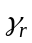 as 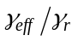 and the degradation curve is expressed as 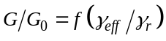, where 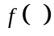 is an arbitrary function. The reference strain is correlated to the effective confining stress 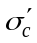 as 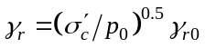 for non-cohesive soils such as sands and gravels, where 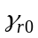 is the reference strain at 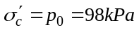. Based on this formulation, the same data are plotted on the chart of G/G₀ versus 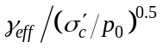 for sand and gravel in Fig.11(e) and (f), respectively. Note that the data dispersions in the modulus ratios become obviously narrower in Figs.11(e), (f) than in Figs.11(c), (d), confirming the significant effect of confining stresses on modulus degradation and damping not only in the laboratory but also in situ.
Another probable reason of the data point scatters still conspicuous particularly in Fig.11(f) may be attributed to the fact that natural gravelly soils normally contain certain amounts of sands, silts and clays. Actually, descriptions of the borehole data in the vertical array sites indicated that some of the gravelly soils contain finer soils although no quantitative information was available. If the finer particles are more than sufficient to fill the voids of gravel particles, they constitute the matrix of the soil, which drastically changes its mechanical properties. In laboratory tests, the critical content of the finer particles for this change to occur seems to be between 10 to 20% for gravelly soils (e.g. Kokusho and Komiyama, 2001). If the content of finer soils exceed the critical values, it may be appropriate to change soil types from gravels to finer soils in judging modulus degradation curves in the field.
Back-calculated damping ratios plotted in Figs.11(a)-(d) for clay, silt, sand and gravel, tend to increase with increasing effective strain irrespective of soil types. These figures do not include several plots of extraordinarily large damping values in a surface fill layer (D=40-50%) and a clay layer underneath (D=27%) in PI evaluated for the main shock (Kokusho and Aoyagi, 2001). The same trend was also found in the previous research based on the least mean square method (Sato et al., 1996; Kokusho et al., 1996). The damping values are judged unreasonable in the light of previous laboratory test data and seem to reflect the effect of intensive liquefaction in the fill layer, indicating limitations involved in the back-calculation method if it is applied to strongly nonlinear systems.
In Figs.12(a) and (b), data points of the back-calculated modulus ratios and damping ratios for different types of soils are superposed on the same charts. For sands and gravels, the values of 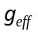 in the horizontal axis are normalized as as explained before. Fig.12(a) clearly indicates that clays are obviously positioned far right, whereas gravels are located far left despite large scatters in the data points. Silts and sands can be judged to stand between the two soils despite large dispersions. Thus, the clear difference in modulus degradation depending on soil types in the laboratory (e.g. Kokusho, 1987) can also be recognizable in the back-calculated soil properties.
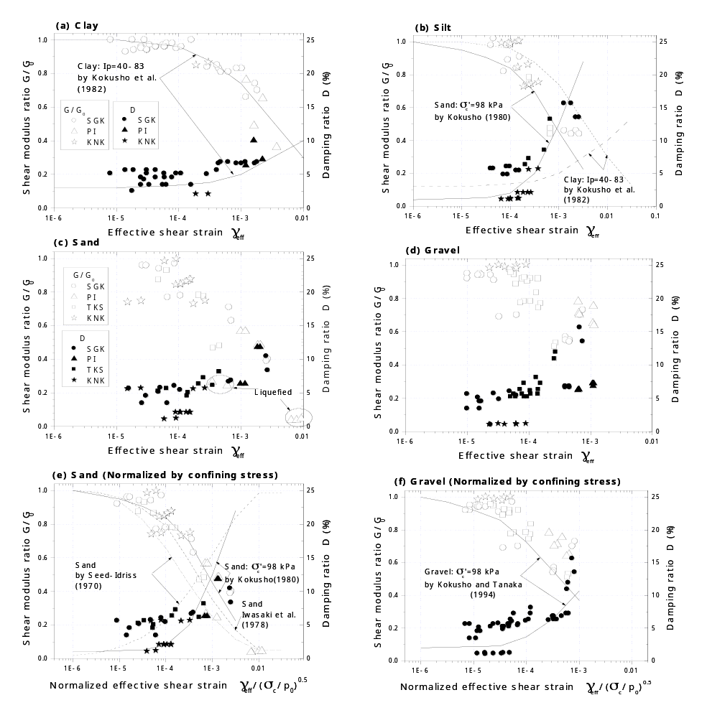
Fig.11 Shear modulus ratios or damping ratios versus reference strains back-calculated at 4 sites for 4 soil types; (a) clay, (b) silt, (c) sand, (d) gravel, (e) sand (reference strain normalized by confining stress), (f) gravel (reference strain normalized by confining stress).

In Fig.12(b), it may be said that damping ratios stay almost constant for small strain range of less than 10⁻⁴ despite widely diverged values from 1 to 6%. Also noted is that damping ratios of gravelly soils are obviously larger than other soils for all strain levels except for several plots in the small strain range. In contrast, clays tend to show smaller damping than other soils. It should be pointed out that damping ratios for small strain at KNK are generally lower (2% or lower) than the other sites irrespective of soil types as indicated in Figs.11(a), (b) and Figs.11(e), (f), splitting the small strain damping values into two groups (4-6% and 1-2%, respectively) as shown in Fig.12(b). It is not clear if this difference reflects actual site specific differences in soil properties or some other factors.
Numerous laboratory tests have been conducted to date since the pioneering work by Seed and Idriss (1970) to establish the strain-dependent changes of modulus and damping on different types of soils. For example, Iwasaki et al. (1978) conducted cyclic loading torsional shear tests of reconstituted sand specimens in which shear moduli and hysteretic damping ratios were measured in a wide strain range from 10⁻⁶ to 10⁻². Kokusho et al. (1980), Kokusho (1982), Kokusho et al. (1982) and Kokusho and Tanaka (1994) carried out improved cyclic triaxial tests for sands, clays and gravels in which inner load cells and high sensitivity proximity sensors were introduced inside pressure chambers so that soil properties could be measured for a wide strain range from 10⁻⁶ to 10⁻². Based on a series of such tests, empirical curves correlating shear modulus ratio G/G₀ or hysteretic damping D with log for sands, clays and gravels were proposed. In the light of accumulated data of quite a few similar laboratory tests, it is generally accepted at present that the modulus degradation curves for sands are positioned more left than those for clays and those of gravels are positioned further left than sands on the G/G₀ versus log chart. Furthermore, the curves for sands and gravels tend to shift rightward with increasing confining pressures. In the following, the back-calculated strain-dependent variations are compared with laboratory values. Note that in evaluating modulus degradations, the initial moduli are defined at 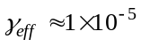 for the back-calculated results versus 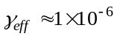 for laboratory test results. This difference may result in slightly milder degradation than laboratory tests although the effect may not be so great as will be indicated in Fig.11.
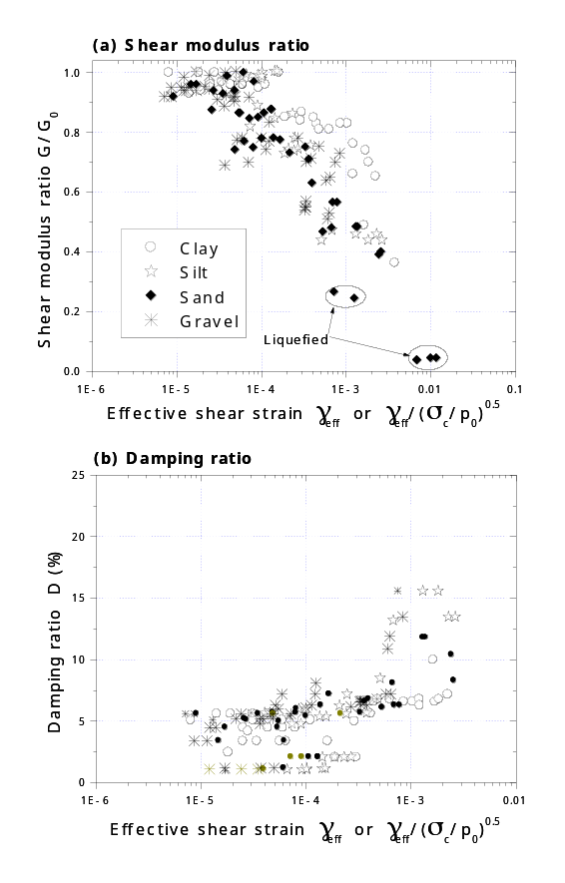
Fig.12 Back-calculated modulus degradations and damping ratios versus reference strains superimposed on the same chart; (a) modulus degradations, (b) damping ratios.

In Fig.11(e), curves of laboratory tests for sands by Iwasaki et al. (1978), Kokusho (1980) and Seed et al. (1986) are drawn to compare with the back-calculated results. The effective confining stress is =98 kPa. Note that the back-calculated modulus degradation shows a fair agreement with one or two laboratory curves out for 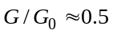 or larger. The curve by Seed et al. (1986) will result in too strong nonlinear effect, though it might be a good estimate for strong modulus degradation corresponding to extensive liquefaction which took place at the PI-site. In Fig.11(f), the similar comparison is made for the degradations of gravels between in situ and laboratory. In this case, the back-calculated modulus degradation is obviously milder than the laboratory curves. This may possibly be attributed that actual gravel soils, unlike pure gravels in the laboratory, normally contain appreciable amount of finer soils and tend to share some of their properties.
In Figs.11(a), the back-calculated modulus ratios of clays are compared with laboratory curves based on the test results of intact alluvial clays (Kokusho et al. 1982). In comparing them, the followings should be borne in mind. Plasticity index, Ip, is known as a decisive factor of modulus degradation curves of clays (e.g. Kokusho, 1982); larger Ip gives milder degradation rate at the same effective strain. Ip-values of clays around the Osaka bay area take a range between 100 and 20 with their majority falling in between 80 and 40, while those of the laboratory test data are I_{P}=40 to 83 and almost coincidental. Agreement of the degradation curves is very good for G/G₀=0.5 or larger, indicating a good consistency in modulus degradation between in situ and laboratory unless nonlinearity exceeds a certain limit. Back-calculated properties of silts are compared in Fig.11(b) with the laboratory curves of clays and sands because of the absence of appropriate laboratory data. It can be pointed out that most of the data points are in between the two degradation curves, indicating a good consistency between in situ and laboratory for silts, too.
With regard to damping ratios, the agreement between in situ and laboratory is evidently poorer than modulus degradations though the back-calculated damping ratios share clear trends of increasing damping with increasing strain. The majority of the back-calculated damping ratios are plotted a few percent higher than most laboratory test results particularly in a strain range smaller than 10⁻⁴ as shown in Figs.11(a),(b),(e) and (f). For clays, in situ damping values tend to increase with increasing strain almost in parallel with the laboratory curve up to 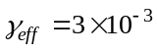 but the former is always larger than the latter by two percent. In other soil types, the clear split in the back-calculated damping values in the small strain range makes straightforward comparison difficult, indicating further research needs for more reliable in situ damping evaluation.

CONCLUSIONS

Main shock records of the 1995 Hyogoken-Nambu earthquake and associated small shock records obtained in four vertical array sites near the seismic fault were incorporated to calculate spectrum amplifications between ground surface and deeper levels. The spectrum ratios for the main shock were mostly smaller in amplitude than those for smaller shocks due to soil nonlinearity. Peak frequencies of main shocks were evidently lower than those of aftershocks. This trend was more pronounced in higher frequency peaks than the first peak because the soil nonlinearity was more dominant in shallower layers. The spectrum ratios at the four sites were then back-calculated to optimize soil properties during the main-shock and the small shocks based on the one-dimensional multi-reflection theory by SH-wave propagation. The reliability of the back-calculation method was examined and found out to be satisfactory at least for linear multi-soil layers models. A series of back-calculations at the four sites and comparisons with laboratory data accumulated to date yielded the following principal conclusions.
- At SGK, where soil properties are optimized for groups of aftershocks independently, clear differences in S-wave velocities can be recognized not only between the main shock and aftershocks but also among aftershocks of different intensities. Damping ratios for the main shock are evidently larger than those for the aftershocks, although the difference is unclear among the aftershocks.
- Clear modulus degradations can be identified from the back-calculated S-wave velocities. The degradions are almost consistent at the four sites, from which soil-specific degradation curves can be differentiated for clay, silt, sand and gravel. The degree of data scatters in modulus degradations for sands and gravels tends to reduce if the effective strains are normalized by effective confining stresses, confirming that confining stresses have significant effect on the degradations of non-cohesive soils.
- Back-calculated damping ratios show clear increasing trends with increasing effective strains in strain range larger than about 10⁻⁴ and stay almost constant in the smaller strains although widely diverged values from 1 to 6% are evaluated there.
- A good agreement in modulus degradation can be recognized between back-calculation and some of previous lab test results for clays and sands unless the degradation exceeds a certain value around G/G₀=0.5. For gravels, milder back-calculated degradations are obtained than laboratory tests. This may reflect the fact that in situ gravelly soils actually contain appreciable fine soils, which should be borne in mind in choosing degradation curves for coarser soils in numerical analyses.
- The majority of the back-calculated damping ratios are a few percent higher than laboratory test results particularly in small strain ranges. Apparent splits in the back-calculated damping values in small strain ranges make straightforward judgment of in situ damping values difficult, indicating further research needs for more refined in situ damping evaluation.

ACKNOWLEDGMENTS

Dr. Suetomi, I. of National Research Institute for Earthquake Science and Disaster Prevention (formerly Researcher in Central Research Institute of Sato Kogyo Com. Ltd.) who kindly provided the computer program of the Extended Bayesian method and helped this analytical research is gratefully acknowledged. The Kansai Electric Power Company and the Kobe Municipal Office who successfully gained the vertical array records and the Committee of Earthquake Observation and Research in Kansai Area (CEORKA) which generously disseminated them are appreciated with gratitude.

REFERENCES

Aoyagi, T. (2000): Inversion analysis for soil properties based on vertical array record using the extended Bayesian method, Master’s thesis, Graduate school of Chuo University.
Elgamal, A., Lai, T., Yang, Z. and He, L. (2001): Dynamic soil properties, seismic downhole arrays and applications in practice, Proc. 4th International Conference on Recent Advances in Geotechnical Earthquake Engineering and Soil Dynamics, San Diego, CD-publication.
Constantopoulos, I. V., Roesset, J. M. and Christian, J. T. (1973): A comparison of linear and exact nonlinear analyses of soil amplification, Proc. 5th International Conference of SMFE, Rome, 1806-1815.
Honjo, Y. (1995): Prior information and model selection in inverse analysis, Tsuchi-to Kiso, Vol.47, No.7 (63-68) and No.8 (51-56) (in Japanese).
Honjo, Y. Iwamoto, S., Sugimoto, M., Onimaru, S. & Yoshizawa, M. (1998): Inverse analysis of dynamic soil properties based on seismometer array records using the Extended Bayesian method. Soils and Foundations: Vol.38, No.1, 131-143.
Iwasaki, and Tatsuoka, F. (1978): Shear moduli of sands under cyclic torsional shear loading, Soils and Foundations, Vol.18, No.1, 39-56.
Kanai,K., Tanaka, T., Yoshizawa, S., Morishita, T., Osada, K. and Suzuki,T. (1966): Comparative studies of earthquake motions on the ground and underground II, Bulletin of the Earthquake Research Institute, Tokyo University, Vol.44, 609-643.
Kokusho, T. & Iwatate, K. (1979): Scaled model tests and numerical analyses on nonlinear dynamic response of soft grounds. Journal of Japan Society for Civil Engineers (in Japanese): III/285, 57-67.
Kokusho, T. (1980): Cyclic triaxial test of dynamic soil properties for wide strain range. Soils and Foundations: Vol.20, No.2, 45-60.
Kokusho, T. (1982): Dynamic soil properties and nonlinear seismic response of ground, PhD Dissertation presented to Tokyo University (in Japanese)
Kokusho,T., Yoshida,Y. and Esashi,Y. (1982): Dynamic soil properties of soft clay for wide strain range. Soils and Foundations: Vol.22, No.4, 1-18.
Kokusho, T. (1987): In-situ dynamic soil properties and their evaluations, Proc. 8th Asian Regional Conf. on SMFE, Kyoto, Theme Lecture, Vol.2, pp.215-235.
Kokusho,T. and Tanaka,Y. (1994): Dynamic properties of gravel layers investigated by in-situ freezing sampling. Geotechnical Special Publication No44 -Ground Failures under Seismic Conditions, ASCE Convention (Atlanta), 121-140.
Kokusho, T. Sato, K. and Matsumoto, M. (1996): Nonlinear dynamic soil properties back-calculated from strong motions during Hyogoken-Nambu Earthquake. Proc. 11th World Conference on Earthquake Engineering, Acapulco, CD publication.
Kokusho, T. & Matsumoto, M. (1998): Nonlinearity in site amplification and soil properties during the 1995 Hyogoken-Nambu earthquake. Special Issue on Geotechnical Aspects of the January 17, 1995 Hyogoken-Nambu Earthquake, No.2; Soils and Foundations: 1-10.
Kokusho, T. and Aoyagi, T. (2001): Insitu nonlinear soil properties back-calculated from vertical array records of 1995 Kobe earthquake, Proc. International Conference on In Situ Measurement of Soil Properties and Case Histories, Indonesian Geotechnical Society, Bali, 473-480.
Kokusho, T. and Komiyama, Y. (2001): Undrained shear characteristics of gravelly soils containing fines, Proc. of Symposium on Mechanical Properties of Gravelly Soils, Japanese Geotechnical Society (in Japanese), 233-238.
Sato, K., Kokusho, T., Matsumoto, M. & Yamada, E. (1996): Nonlinear seismic response and soil property during 1995 Hyogoken Nanbu earthquake. Special Issue on Geotechnical Aspects of the January 17, 1995 Hyogoken Nambu earthquake. Soils and Foundations: 41-52.
Schnabel, P.B., Lysmer, J. & Seed, H.B. (1972): SHAKE, A computer program for earthquake response analysis of horizontally layered sites. Report EERC 72-12, University of California Berkeley.
Seed, H.B. and Idriss, I. M. (1970): Soil Moduli and damping factors for dynamic response analysis, Report EERC 70-10, University of California Berkeley.
Seed, H. B., Wong, R. T., Idriss, I. M. and Tokimatsu, K. (1986): Moduli and damping factors for dynamic analyses of cohesionless soils, Journal of Geotechnical Engineering, Vol.112, No.11, 1016-1032.
Suetomi, I. and Nakamura, S. (1990): Considerations on effect of non-uniformity of soil properties on seismic site response. Proc. Japan Earthquake Engineering Symposium, Japan Society for Civil Engineers (in Japanese), 97-100.
Suetomi, I. (1997): A Program manual for optimization of soil structure by Bayes Method. Central Research Institute of Sato Kogyo Com. Ltd, (in Japanese).

